INTRODUCTION

Project overview
Traditional blood bank operations in many local settings still rely on manual records, phone calls, and informal communication between hospitals, donors, and blood banks. Such a system is slow, error-prone, and difficult to coordinate during emergencies. The lack of centralized information leads to duplicated records, delayed donor identification, and poor visibility into blood availability. As a result, patients in urgent need of blood often face avoidable delays, while blood banks struggle to manage requests and maintain updated inventory.
Blood Link proposes a web-based Blood Bank Management System that centralizes the entire coordination process. Through a unified digital platform, donors can register and update their profiles, hospitals can submit blood requests, and blood banks can review availability and approve or reject requests based on stock and compatibility. Administrators can monitor the overall activity of the system, ensuring controlled access and proper workflow management. This digitized approach reduces manual dependency and improves communication among all stakeholders.
The main objectives of Blood Link are to streamline donor and request management, maintain accurate and up-to-date blood inventory records, improve emergency response time, and provide secure role-based access for different user types. The system also aims to enhance data consistency, reduce administrative workload, and support efficient decision-making through structured record keeping and status tracking.

Introduction to Tools
Python
Python is a high-level, interpreted programming language widely used for web development, data processing, automation, and application scripting. It is known for its simple syntax, readability, and strong community support, which make it suitable for developing reliable and maintainable software systems. In the Blood Link project, Python serves as the core backend language for implementing business logic, processing user requests, and managing system workflows.
- Python is an open-source, object-oriented programming language.
- It supports rapid application development with clear and concise syntax.
- Python provides extensive libraries and frameworks for web applications, database interaction, and security.
- It is platform independent and can run on multiple operating systems.
- Python is highly suitable for server-side programming and data-driven applications.
Django
Django is a high-level Python web framework that enables the rapid development of secure and scalable web applications. It follows the model-view-template architectural pattern and includes built-in features for authentication, routing, form handling, and database management. In Blood Link, Django is used to develop the web interface, manage user roles, handle request processing, and connect the frontend with the database.
- Django is a Python-based framework designed for fast and efficient web development.
- It promotes clean design and reduces repetitive coding through built-in components.
- Django includes strong security features such as protection against common web vulnerabilities.
- It supports authentication, session management, and administration tools by default.
- It integrates easily with relational databases and supports scalable application development.
SQLite
SQLite is a lightweight, serverless relational database management system used for storing and retrieving application data. It is embedded directly into the application and does not require a separate database server, making it ideal for small and medium-scale projects. In Blood Link, SQLite is used to store donor records, blood requests, inventory details, and user account information efficiently.
- SQLite is a compact and self-contained database engine.
- It requires minimal configuration and is easy to deploy.
- SQLite supports standard SQL queries for data manipulation and retrieval.
- It is suitable for academic and prototype-level web applications.
HTML
HTML (HyperText Markup Language) is the standard markup language used to structure web pages. It defines the layout and organization of content displayed in a browser. In the Blood Link project, HTML is used to design pages such as login forms, registration forms, dashboards, and request interfaces.
- HTML provides the structural foundation of web pages.
- It allows the creation of forms, tables, buttons, and navigation elements.
- HTML works together with CSS and JavaScript to create interactive interfaces.
- It is supported by all modern web browsers.
- It is essential for presenting data in a structured and user-friendly format.
CSS
CSS (Cascading Style Sheets) is used to control the visual presentation of web pages. It defines the color scheme, layout, spacing, typography, and responsiveness of the interface. In Blood Link, CSS is used to create an organized and visually consistent user experience across different pages.
- CSS is used to style and enhance the appearance of HTML pages.
- It supports responsive design for different screen sizes and devices.
- CSS improves readability and usability through better layout control.
- It separates content structure from visual design.
- It helps maintain a consistent interface throughout the application.
JavaScript
JavaScript is a client-side scripting language used to add interactivity and dynamic behavior to web applications. It allows web pages to respond to user actions without requiring a full page reload. In Blood Link, JavaScript can be used for form validation, dynamic updates, and improving the responsiveness of the user interface.
- JavaScript enables interactive web page functionality.
- It supports event handling, validation, and dynamic content updates.
- It improves the overall user experience of web applications.
- It works alongside HTML and CSS to build modern interfaces.
- It is supported by all major web browsers.
- SQLite Database Browser and Development Tools

Development tools are used to simplify coding, testing, and database management during application development. For the Blood Link project, tools such as a code editor, browser, and database management utilities are used to develop and test the system effectively. These tools support debugging, interface testing, and data verification throughout the project lifecycle.
- Code editors provide a convenient environment for writing and organizing source code.
- Web browsers are used to test page rendering and application behavior.
- Database tools assist in viewing, editing, and verifying stored records.
- Development tools improve productivity and reduce implementation errors.
- They support efficient testing and maintenance of the application.

SYSTEM STUDY

Introduction
A system is set of interrelated elements that collectively work together in order to achieve a common goal. A sub system is that part of a system that carries one part of a system function. System study refers to the process of examining business situations with the aim of improving it through better procedure and method. System designing is the process of planning a new business system or one to replace all component and existing system. However, before tis planning one must have true idea about existing system.

Feasibility study
An important outcome of the preliminary investigation is the determination that the system requested is feasible. The feasibility of the project can be ascertained in terms of technical factors, or both. There are three aspects in the feasibility study portion of the preliminary investigation.
- Technical Feasibility
- Economic Feasibility
- Operational Feasibility

Technical Feasibility
Can the work for the project be done with equipment, existing software technology and available personnel? If new technology is needed, what is the likelihood that it can be developed? Technical feasibility refers to the ability of the process to take advantage of the current state of the technology in pursuing further improvement.
It was found that the firm currently using computers and printers for creating documents and drawings. As this machine is configured for the basic hardware requirements for installing dot net framework the equipment is feasible for installing the designed software. The operating system is installed in these computers is compatible for installing the dot net framework. The staff in the firm is now manually preparing all functions mentioned in the study of the software. So if they get trained with this designed software, new appointments can be avoided and thus the system will run smoothly.
Economic Feasibility
Are there sufficient benefits in creating the system to make the cost acceptable? Or, are the costs of not creating the system so great that it is advisable to undertake the project? This involves the feasibility of the proposed project to generate economic benefits by swapping to this software system the firm is completely wiped out from its manual paper works and files. Now the entire system will be controlled and maintained by the newly developed software that doesn’t require any kind of these existing materials. So the cost is reduced and the burden of keeping these materials for the lifetime is evacuated forever. The entire control of each function comes under one umbrella and thus for reporting the required information is reduced.
Operational Feasibility
Will the system be used if it is developed and implemented? Will there be resistance from users that will undetermined the possible application benefits? Since the software system is designed in a user-friendly manner. It is easy to understand the working process for a computer aware person. Training is provided for the users of this software. The benefits are thoroughly practiced at the time. The burdens that they currently followed are compared with these software functions and visualized how ease the software handles those situations. Thus they are motivated to shift to the new environment without any fake thoughts in mind.
Existing System
In the existing blood bank management process, most activities are carried out manually or through disconnected communication channels such as telephone calls, paper registers, and informal record keeping. Donor details, blood inventory, and patient requests are often maintained separately, making it difficult to coordinate blood availability in real time. When an emergency request arises, staff must manually search for compatible donors or available stock, which increases response time and administrative workload.
Disadvantage of Existing System:
- Data is stored in an unorganized and fragmented manner.
- Manual record keeping increases the chances of human error.
- Blood request processing is slow during emergencies.
- Tracking donor availability and blood stock is difficult.
- Communication between hospitals, donors, and blood banks is inefficient.
- Duplicate records and outdated information may occur.
Proposed System
The proposed Blood Link system is a web-based Blood Bank Management System that centralizes donor registration, blood request handling, inventory management, and approval workflows in a single platform. It enables different users such as donors, hospitals, blood bank staff, and administrators to interact through role-based access. The system improves coordination by maintaining updated records and supporting faster decision-making.
Advantage of Proposed System:
- Centralized and organized storage of blood bank data.
- Faster processing of donor registration and blood requests.
- Reduced manual work and fewer chances of error.
- Real-time tracking of blood inventory and donor information.
- Improved communication among hospitals, donors, and blood banks.
- Secure and efficient role-based access for different users.
- Better emergency response through quicker availability checks.

Techniques for System study
The analyst collects data from two principle sources.
- Written documents
- Data from the persons who are involved in the operation of the system under study.
The different fact finding techniques are:
- Data carriers
- Questionnaires
- Personal interviews
- Observations
- Research
Data carrier
In this step, the analyst gathers and gathers all documentation related to data carriers for the system under investigation. Examples of data carriers are forms, records, reports, manuals and procedures.
Questionnaires
The questionnaire is an important and often effective type of correspondence. For example, it may be the only efficient method of obtaining response from a large number of people particularly if they are widely scattered or in a remote locations. Questionnaire should be brief in order to increase the promptness and portability of correspondence.
Personal interviews
An interview is a person-to-person communication. The analyst is more of a receiver than a sender when conducting an interview. The interviews are helpful for the analyst to explain the actual aim of the interview. The analyst is primarily seeking information. Therefore, he must be a good listener. Interviews are critical because people are the most important ingredients of any system.
Observation
In this method analyst observes the operation of the ongoing system and begins to formulate questions and draw conclusions based on what he/she observed. Skilled analyst is able to observe things and recall it in a quick way.

Research
The final fact-finding techniques, research is of particular importance when a new application is being considered because it is a method of simulating creative approach to the problem solving. All the fact-finding methods that are discussed are in house research. However there are many outhouse source of information, these include trade and professional publication, computer oriented news publication etc. an analyst should establish and maintain contacts with officials in other companies. One highly recommended method of making such contact is membership and active participation in professional societies. Also visit various companies with similar problems and exchanging information and ideas will helpful for the analyst for attaining knowledge. This knowledge will help the analyst for making various decisions. The fact-finding techniques used in our project is data carriers and interviews, to collect data for computerizing the existing system. In data carriers, we gathered and organized all documentations related to data carries for the system under investigation. In interviews, we have collected the information regarding the existing system and drawbacks to be cleared.

SYSTEM ANALYSIS

Introduction
A system is set of interrelated elements comprised and operating together to achieve goals. In computer field a system can be regarding as a set of interacting elements responsible for input to produce outputs. The inputs of system are considered as raw data refined outputs are called information. It may be better to define the term “System Analysis” and “System Analyst” in the context. System analysis is general term refer to an orderly structured process for an orderly structured process for identifying and solving problems. A system analyst is an individual who performs the system analysis during any or all lifecycle phases of a business information system.
System Analysis is a detailed study of the various function performed by the system and the relationship within and outside of the system. In this phase, the problem is identified and alternates system solution for solving it is recognized. System Analysis not only includes the process of synthesis, which is a process of putting parts together to form a new product. Analysis involves the requirement identification and specification.
Software Requirement Specification
The software requirements specification (SRS) is a means of translating the ideas in the minds of clients into a formal documentation. This document forms the development and software validation. The basic reason for the difficulty in software requirement specification comes from the fact that there are three interested parties- the clients, the end users and the software developer. The requirements document has to be such that the client and the user can understand easily, and the developers can use it as a basis for software development. Due to the diverse parties involved in software requirement specification, a communication gap exists. This gap arises when the client does not understand software or the software development processor when the developer does not understand the client’s problem and application area of SRS bridges this communication gap. Problem analysis is done to obtain a clear understanding of the needs of the clients and the users, and what exactly is desired from the software. Analysis leads to the actual specification. People performing the analysis called analysts, area also responsible for specifying the requirements. The software project is initiated by the client’s needs. In the beginning these needs are in the minds of various people in the client organization. The requirement analyst must identify their requirements by talking to these people and understanding their needs. These people and the existing documents about the current mode of operation are the basis source of information for the analyst.
Software Requirements
- Operating System: Windows 10/11 or equivalent
- Backend Language: Python 3.x
- Web Framework: Django
- API/Data Handling: Django REST Framework, if used for structured serialization and endpoints
- Frontend Technologies: HTML5, CSS3, JavaScript
- Database: SQLite3
- Web Browser: Google Chrome, Microsoft Edge, or Mozilla Firefox
- Development Environment: Visual Studio Code or any Python-compatible IDE
- Python Package Management: pip
- Version Control: Git, if source control is required
Hardware Requirements
- Processor: Intel Core i3 or higher
- RAM: Minimum 4 GB, recommended 8 GB
- Storage: Minimum 1 GB free space for application files and database
- Display: 1366 x 768 resolution or higher
- Input Devices: Keyboard and mouse
- Network: Internet connection for deployment, updates, or online access

USE CASE

USE CASE
A Blood Bank Management System can have multiple use cases depending on its purpose and functionality.
Here are some possible use cases:
User Authentication and Role-Based Access
• Allows donors, hospitals, blood bank staff, and administrators to log in using valid credentials.
• Provides separate access permissions for each user role.
Donor Management
• Adds, updates, views, and manages donor records.
• Stores donor details such as name, blood group, contact number, address, and availability status.
Hospital Management
• Adds, updates, views, and manages hospital details.
• Stores hospital information such as hospital name, contact person, location, and registration details.
Blood Inventory Management
• Adds, updates, views, and deletes blood stock details.
• Maintains blood group-wise availability and stock quantity for each hospital or blood bank.
Donation Appointment Request
• Allows donors to request donation appointments with a hospital or blood bank.
• Stores appointment date, health response, notes, and eligibility status.
Blood Request Processing
• Allows hospitals or authorized users to raise blood requests for required blood groups and units.
• Stores request status such as pending, approved, completed, or rejected.
Request Approval and Completion
• Enables hospital staff or administrators to approve blood requests.
• Updates inventory and request status after blood is issued or the request is completed.
Administrative Monitoring
• Allows administrators to view hospitals, donors, appointments, blood requests, and inventory summaries.
• Helps in monitoring system activity and maintaining proper records.

SYSTEM DESIGN

4.1 Introduction
The design phase focuses on the detailed implementing procedural flowchart of the system recommended in the feasibility study. Emphasis in translating performance specification into design specification. The design phase is a translation from a user-oriented document to the programmers or database personal. System design aims to identify the modules and how they interact with each other to procedure-desired results. At the end of system design all data structures, file formats, output formats, as well as the major modules in the system and their specifications and desired

Module Specification
The Blood Link system consists of four primary users: Administrator, Blood Bank Staff, Hospital, and Donor. It includes several functional modules that support blood donation coordination, request handling, inventory control, and user management. Users can register or log in to access their respective services securely. The Administrator manages the entire system, while the remaining users perform role-specific operations within the platform.
The system consists of the following modules:
- Registration / Login Module
- User Management Module
- Blood Request and Approval Module
- Blood Inventory and Donor Management Module
- View and Report Module
1. Registration / Login Module
In this module, the users of the system such as donors, hospitals, blood bank staff, and administrators can register or log in to the Blood Link system. New users must complete secure registration with relevant personal and organizational details. Existing users can log in using valid credentials. This module ensures authenticated access and allows each user to enter the system based on their assigned role.
2. User Management Module
This module is mainly controlled by the administrator. The administrator can manage user accounts, activate or deactivate profiles, and maintain role-based access for donors, hospitals, and staff. It helps in maintaining accurate user records and ensures that only authorized users can access the system functions.
3. Blood Request and Approval Module
In this module, hospitals can submit blood requests by specifying blood group, quantity, urgency level, and patient requirements. The blood bank staff or administrator can review the request, verify availability, and approve or reject it based on stock and compatibility. This module supports faster emergency response and transparent request processing.

4. Blood Inventory and Donor Management Module
In this module, the blood bank staff can update blood stock details, monitor available units, and maintain inventory records. Donors can update their availability status and profile details. The system keeps track of donor information and blood availability, which helps in quick matching during urgent blood requirements.
5. View and Report Module
This module allows users to view relevant details based on their role. Administrators can view all system records, hospitals can view request statuses, donors can view their profiles and availability, and staff can monitor blood stock and request information. The system can also generate reports related to donor records, blood inventory, and request history for effective management and decision-making.

Input Design
Input designing is the process of converting user-oriented data into computer-based formats for processing and storage. Input is the primary source of data in the system, and therefore it must be designed carefully to reduce errors, improve accuracy, and ensure ease of use. In the Blood Link system, input forms are structured according to user roles so that donors, hospitals, blood bank staff, and administrators can enter and manage information efficiently.
The input forms used are:
FORMS:
Admin
- FRM_LOGIN
This form is used by the administrator to log in to the system using a valid username and password.
- FRM_DASHBOARD
This form is used to view overall system details, monitor blood requests, donor registrations, and inventory status.
- FRM_USER_MANAGEMENT
This form is used to add, update, activate, or deactivate donor, hospital, and staff accounts in the database.
- FRM_BLOOD_INVENTORY
This form is used to add and update blood stock details, blood group availability, and quantity in storage.
- FRM_REQUEST_APPROVAL
This form is used to view hospital blood requests and approve or reject them based on stock availability.
- FRM_REPORTS
This form is used to view and generate system reports such as donor details, request history, and blood stock summaries.

Donor
- FRM_REGISTER
This form is used by donors to create a new account in the system.
- FRM_DONOR_PROFILE
This form is used to enter and update donor details such as blood group, contact information, address, and availability status.
- FRM_LOGIN
This form is used by registered donors to log in to the system using valid credentials.
- FRM_AVAILABILITY
This form is used to update donor availability for donation when required.

Hospital
- FRM_REGISTER
This form is used by hospitals to register into the system.
- FRM_LOGIN
This form is used by hospitals to log in using valid credentials.
- FRM_BLOOD_REQUEST
This form is used to submit blood requests by entering blood group, quantity, urgency level, and patient-related details.
- FRM_REQUEST_STATUS
This form is used to view the status of submitted blood requests.
Blood Bank Staff
- FRM_LOGIN
This form is used by blood bank staff to access the system securely.
- FRM_DONOR_VIEW
This form is used to view registered donor details and availability.
- FRM_STOCK_UPDATE
This form is used to update blood stock, issue records, and availability details.
- FRM_REQUEST_PROCESS
This form is used to review and process incoming hospital blood requests.
- FRM_NOTIFICATION_VIEW
This form is used to view alerts, approvals, and system notifications.

Output Design
An output is the most important and direct source of information to the user. Efficient and intelligent output design improves the system relationship with the user and helps in decision-making.
Once the output required are identified the output device used also should be determined factors like compatibility of the output device used also should be determined factors like compatibility of the output device with the system response requirement should be considered while deciding the output device. They are designed in such a way that all required information’s are conveyed to the user in a very clear and efficient way.
Database Design
Database design is the process of producing a detailed data model of a database. This data model contains all the needed logical and physical design choices and physical storage parameters needed to generate a design in a data definition language, which can then be used to create a database. A fully attributed data model contains detailed attribute for each entity.
The term database design can be used to describe many different parts of the design of an overall database system. Principally, and most correctly, it can be thought of as the logical design of the base data structures used to store the data. In the relational model these are the tables and views. In an object database the entities and relationship map directly to object classes and named relationship. However, the term database design could also be used to apply to the overall process of designing, not just the data structures, but also the forms and queries used as part of the overall database application within the database management system (DBMS).
The process of doing database design generally consists of a number of steps which will be carried out by database designer. Usually, the designer must:
- Determine the data to be stored in the database.
- Determine the relationship between the different data elements.
- Superimpose a logical structure upon the data on the basis of these relationships.

Within the relational model the final step above can generally be broken down into two future steps that of determining the grouping of information within the system, generally determining what are the basis objects about which information is being stored, and then determining the relationship between these groups of information, or objects. This step is not necessary with an object database.

NORMALIZATION
Designing a database is complete task and the normalization theory is a useful aid in the design process. The process of normalization is concerned with transformation of conceptual schema into computer representation form. There will be need for most databases to grow by adding new attributes and new relations. The data will be used new ways. Tuple will be added and deleted. Information stored may undergo updating also. New association may also be added. In such situation the performance of a database is entirely depend upon its design. A bad database design may lead to certain undesirable things like:
  - Repetition of information
  - Inability to represent certain information.
  - Loss of information
To minimize these anomalies, normalization may be used. If the database is in a normalized from, the data can be growing without, in most cases, forcing the rewriting application programs. This is important because of the excessive and growing cost of maintaining an organization’s application programs and its data 4from the disrupting effects of database growth. As the quality of application programs increase, the cost of maintaining the without normalization will rise to prohibitive levels, A normalized database can also encompass many related activities of an organization thereby minimizing the need for rewriting the applications of programs. Thus, normalization helps one attain a good database design and there by ensures continued efficiency of database.
We can define the procedure as the successive reduction of a given collection of relations to some more desirable from. This procedure is reversible. That is, it is always possible to take the output from the procedure and convert them back into input. In this process, no information is lost. So, it is also called “no lose decomposition”.
1. FIRST NORMAL FORM:
A relation is first normal form (1NF) if and all its attributes are based on single domain. The objective of normalization a table is to remove its repeating groups and ensure that all entries of the resulting table have at most single value.
2. SECOND NORMAL FORM:
A table is said to be second normal form (2NF), when it is in 1NF and every attribute in the record is functionally dependent upon the whole key, and not just a part of the key.
3. THIRD NORMAL FORM:
A table is in third normal form (3NF). When it is in 2NF and every non-key attribute is functionally dependent on just the primary key.
4. BCNF (Boyce–Codd Normal Form):
A table is in BCNF if, for every non-trivial functional dependency, the determinant is a candidate key. It eliminates redundancy and anomalies caused by functional dependencies more effectively than 3NF.
5. FOURTH NORMALFORM:
Fourth Normal Form eliminates redundancy caused by independent multivalued dependencies. A table is in 4NF when it is in BCNF and contains no nontrivial multivalued dependencies.
6. FIFTH NORMALFORM:
Fifth Normal Form eliminates redundancy caused by join dependencies. A table is in 5NF when every join dependency is implied by candidate keys, ensuring lossless decomposition.

TABLES
- User table
This table stores the login and basic profile information of all users in the Blood Link system, such as name, username, password, email, role, and account status.
Primary Key: user_id
Field Name | Data Type | Size | Description
user_id | Int | 11 | User ID
name | Varchar | 50 | Full name
username | Varchar | 30 | Username
password | Varchar | 30 | Password
email | Varchar | 50 | Email address
role | Varchar | 20 | User role
status | Varchar | 20 | Account status

- Donor
This table contains the personal and medical details of registered blood donors, including blood group, age, gender, contact number, address, and availability status.
Primary Key: donor_id
Field Name | Data Type | Size | Description
donor_id | Int | 11 | Donor ID
user_id | Int | 11 | User reference ID
age | Int | 3 | Age of donor
gender | Varchar | 10 | Gender
blood_group | Varchar | 5 | Blood group
contact_number | Varchar | 15 | Contact number
address | Varchar | 100 | Residential address
availability_status | Varchar | 20 | Availability status

- Hospital
This table stores the information about hospitals registered in the system, including hospital name, contact person, contact number, and address.
Primary Key: hospital_id
Field Name | Data Type | Size | Description
hospital_id | Int | 11 | Hospital ID
user_id | Int | 11 | User reference ID
hospital_name | Varchar | 100 | Hospital name
contact_person | Varchar | 50 | Contact person
contact_number | Varchar | 15 | Contact number
address | Varchar | 100 | Hospital address

- Blood bank
This table contains the details of blood bank branches or centers, such as bank name, location, and contact number, to manage blood storage and supply.
Primary Key: bank_id
Field Name | Data Type | Size | Description
bank_id | Int | 11 | Blood bank ID
user_id | Int | 11 | User reference ID
bank_name | Varchar | 100 | Blood bank name
location | Varchar | 100 | Blood bank location
contact_number | Varchar | 15 | Contact number

- Blood inventory
This table stores the current stock of blood available in each blood bank, including blood group, quantity available, and last updated time.
Primary Key: inventory_id
Field Name | Data Type | Size | Description
inventory_id | Int | 11 | Inventory ID
bank_id | Int | 11 | Blood bank reference ID
blood_group | Varchar | 5 | Blood group
quantity_available | Int | 11 | Available blood units
last_updated | DateTime | - | Last update time

- Blood request
This table contains the requests submitted by hospitals for blood units, along with blood group, quantity required, urgency level, request date, and request status.
Primary Key: request_id
Field Name | Data Type | Size | Description
request_id | Int | 11 | Request ID
hospital_id | Int | 11 | Hospital reference ID
blood_group | Varchar | 5 | Required blood group
quantity_required | Int | 11 | Required units
urgency_level | Varchar | 20 | Urgency level
request_date | Date | - | Request date
status | Varchar | 20 | Request status

- Donation
This table stores the records of blood donations made by donors, including donated blood group, donation date, quantity donated, and donation status.
Primary Key: donation_id
Field Name | Data Type | Size | Description
donation_id | Int | 11 | Donation ID
donor_id | Int | 11 | Donor reference ID
blood_group | Varchar | 5 | Donated blood group
donation_date | Date | - | Donation date
quantity_donated | Int | 11 | Donated units
status | Varchar | 20 | Donation status

- Approval
This table contains the approval or rejection details of blood requests, including the approving user, approval date, status, and remarks.
Primary Key: approval_id
Field Name | Data Type | Size | Description
approval_id | Int | 11 | Approval ID
request_id | Int | 11 | Blood request reference ID
approved_by | Int | 11 | Approved by user ID
approval_date | Date | - | Approval date
approval_status | Varchar | 20 | Approved / Rejected
remarks | Varchar | 200 | Additional comments

- Notification
This table stores alerts and messages sent to users regarding requests, approvals, updates, or system activities.
Primary Key: notification_id
Field Name | Data Type | Size | Description
notification_id | Int | 11 | Notification ID
user_id | Int | 11 | User reference ID
message | Varchar | 255 | Notification message
created_at | DateTime | - | Message creation time
read_status | Varchar | 20 | Read / Unread

DATA FLOW DIAGRAM

Data Flow Diagram
Data flow Diagram is the important structure tool. A Data Flow Diagram models a system by using external entries from which data flows to a process which transforms the data and create output data which goes into other process as output.
The main merit of Data Flow Diagram is that it provide an overview of what data a system would process, what transformation of data are done, what files are used and where the results flow. The graphical representation of the system makes it good communication tool between the user and analyst.
It is difficult to understand the business through verbal description alone. Here Data Flow Diagram helps in illustrating the essential components of a process and the way they interact.
The symbols used Data Flow Diagram has been explained below.
In a DFD, there are mainly four symbols
- A square defines a source of destination of system data.

- An arrow identifies data flow or data in motion. It is a pipeline through which information flows.

- An arrow identifies data flow or data in motion. It is a pipeline through which information flows.

- An open rectangle is a data source or data at rest or a temporary storage of data constructing the DFD.

Level 0

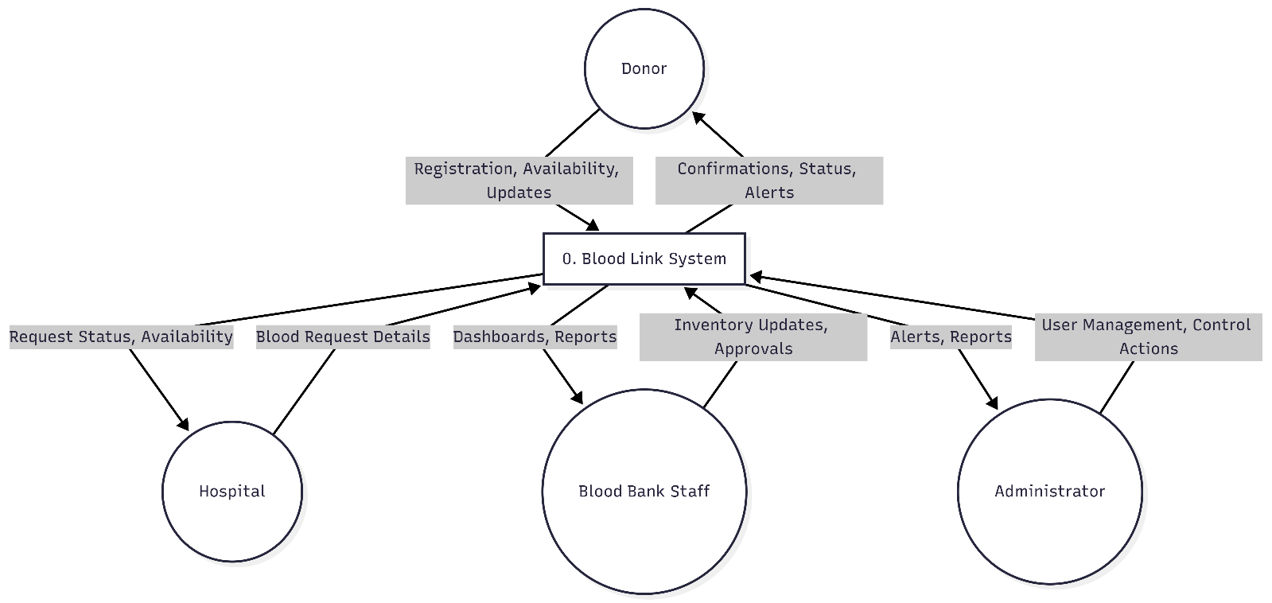

Level 1
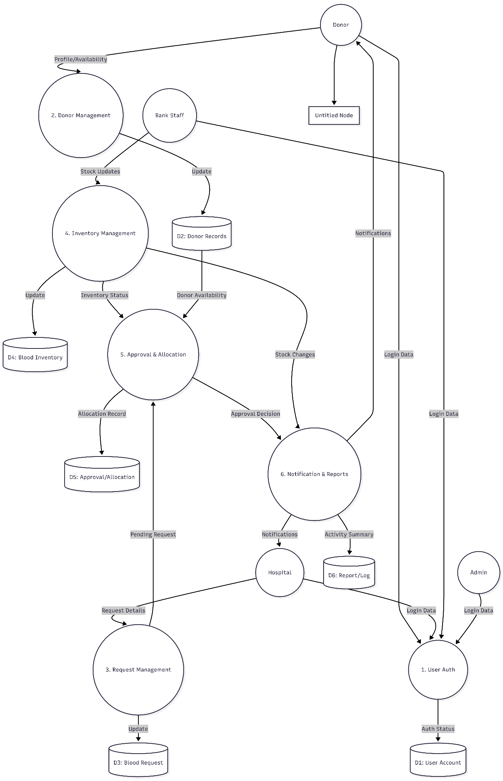

SYSTEM TESTING
AND
IMPLEMENTATION

Testing
System testing is the stage of implementation, which is aimed at ensuring that the system works accurately and efficiently before live operation commence. The logical design and the physical design should be thoroughly and continually examined on paper ensure that they will work when implemented. The various tests performed on the proposed system were based on Volume. A large number of records were created and it was verified whether the hardware and software of the proposed system functioned properly. The user provided test data.
Recovery and Security
A forced system failure is induced to test the backup recovery procedure for file integrity. Inaccurate data were entered to see how the system responds in terms of error detection and protection appropriate error message are displayed.
Usability documentation and procedure:
The usability test verifies the user-friendly nature of the system. In addition, the functionality of the user interfaces features, such as command button, function keys; tools such as icons and so on were verified.
Testing is divided into four distinct operations:
- Unit testing
- Integration testing
- Alpha testing
- Beta testing
Unit Testing
It is also known as program testing. Unit testing is a method of testing that verifies the individual units of source code are working properly. A unit is a smallest testable part of an application. In unit, testing important control paths are tested to uncover errors within the boundary of the module. As soon as code is developed, it has to be tested. It is based on the code that the entire application works. Hence, care has to be taken to ensure perfection in all stages of testing a code. Unit testing can be done in three different stages.
- Self review: The first step of testing code developed is done by the developer himself.
- Peer review: Code must be tested by any one of the team members other than the developer.
- SQA review: The final stage of testing the code is done by member of the software quality assurance (SQA) team.

Integration Testing
Integration testing is the phase of software testing in which individual software modules are combined and tested as a group, integration takes as its input modules that have been unit tested, groups them in larger aggregates, applies tests that are defined in the test plan. Some different type of integration testing are as follows:
Big Bang:
In this approach, all or most of the developed modules are coupled together to form a complete software system and then used for integration testing
Bottom Up:
The bottom up or low level modules, procedures or functions are integrated and then tested. After the integration testing of lower level integrated modules. The next level of modules will be formed and can be used for integration testing.
Top Down
The top down method is an incremental approach to the construction of program structure. Modules are integrated and tested by moving downward. Through the control hierarchy, beginning with the main program module. Then the modules subordinate to the main program module are integrated and tested.
Alpha Testing
In alpha testing, the users are invited at the development center where they use the application and the developers note every particular input or action carried out by the user. Any type of abnormal behavior of the system is noted and rectified by the developers.
Beta Testing
In beta testing the software is distributed as a beta version to the users and users test the application at their sites. 1The implementation stage is a system project in its own right. It includes careful planning, investigation of current system and its constraints on implementation, design of methods to achieve the changeover, training of the staff in the changeover procedure and evaluation of the changeover method.
The first task in implementation is planning deciding on the methods and time scale to be adopted. Once the planning has been completed the major effort is to ensure that the program in the system are working properly when the staff has been trained, the complete system involving both computer and user can be execute effectively. Thus, the clear plans are prepared for the activities. Successful implementation of the new system design is a critical phase in the system life cycle. Implementation means the process of converting a new or revised system design into an operational one.
This involves the following:
- Creating computer compatible files.
- Training the operating staffs.
Implementation
Implementation is the stage of the project when the theoretical design is turned into a working system. The implementation stage is a system project in its own right. It includes careful planning, investigation of current system and its constraints on implementation, design of methods to achieve the changeover, training of the staff in the changeover procedure and evaluation of the changeover method.
The first task in implementation is planning deciding on the methods and time scale to be adopted. Once the planning has been completed the major effort is to ensure that the program in the system are working properly when the staff has been trained, the complete system involving both computer and user can be execute effectively. Thus, the clear plans are prepared for the activities.
Successful implementation of the new system design is a critical phase in the system life cycle. Implementation means the process of converting a new or revised system design into an operational one. This involves the following:
Training
- Training is a vital part of the computer based information system. The main aim of training is to make aware of the system concepts to users in detail. The training focuses on two issues
- Use capabilities
- Name of the system being installed.
The training section that are given to the operators and end users are different. The operators need to know the concept of the system in deep. But the end user training is only concerned with low how to perform the program and how to access the transaction details. There are mainly three types of training:
- Brain storming section
- Seminar
- Computer awareness training

Brain storming section
It is a method of fact-finding techniques and unknowingly the participants can be made aware of various system concepts.
Seminar
In the seminar the emphasis has to laid on the various features of the system. Use of various reports input and output procedures etc. After the seminar if require a practical workshop can be organized in order to have proper control over the operational staff.
Computer awareness training (Technical training)
Training is given based upon the environment in which the system is running and various software environments helping the working of the system.

CONCLUSION
AND
FUTURE ENHANCEMENT

Conclusion
Blood Link is a comprehensive Blood Bank Management System designed to improve the efficiency and reliability of blood donation and distribution activities. The project addresses the limitations of traditional manual systems, where donor information, blood stock, and hospital requests are often managed through disconnected records and slow communication methods. By introducing a centralized web-based platform, Blood Link enables faster registration, easier request handling, accurate inventory tracking, and better coordination among donors, hospitals, blood banks, and administrators. This results in reduced administrative burden, improved data organization, and quicker response during emergency situations when blood is urgently required. The system also enhances transparency and accountability through structured workflows and role-based access control. In addition, it provides a strong foundation for future expansion by supporting additional features such as notifications, advanced reporting, and multi-branch synchronization. Overall, Blood Link contributes to the modernization of blood bank operations and demonstrates how technology can be effectively applied to support healthcare services and save lives.

Future enhancement
The Blood Link system can be extended in several ways to improve its functionality, scalability, and real-world usability. In the future, the application can be upgraded to include real-time SMS and email notifications for urgent blood requests, donor reminders, and approval updates. The system may also be enhanced with geolocation-based donor search to quickly identify nearby eligible donors during emergencies. In addition, the platform can be expanded into a cloud-based multi-branch architecture to support multiple hospitals and blood banks with centralized synchronization. Advanced analytics and reporting features can further be added to predict blood demand, monitor donation trends, and optimize inventory planning for better healthcare service delivery.
- The system can be enhanced with real-time SMS and email notifications to alert donors, hospitals, and blood bank staff instantly during emergencies.
- A geolocation-based donor search feature can be added to identify nearby eligible donors quickly.
- The project can be expanded into a cloud-based multi-branch system to support multiple hospitals and blood banks from a central platform.
- Mobile application support can be introduced so users can access the system more conveniently through smartphones.
- Advanced analytics and forecasting can be implemented to predict blood demand and manage inventory more effectively.
- The system can include QR code or barcode-based blood unit tracking for better traceability and stock management.
- Integration with health records and donor history can be added to improve donor eligibility checks and request accuracy.
- A multilingual interface can be developed to make the application accessible to a wider range of users.

BIBLIOGRAPHY

Bibliography
- https://docs.djangoproject.com/
- https://www.python.org/doc/
- https://www.sqlite.org/docs.html
- Software Engineering by Ian Sommerville
- Object-Oriented Software Engineering by Timothy C. Lethbridge and Robert Laganière

APPENDIX A

Login page
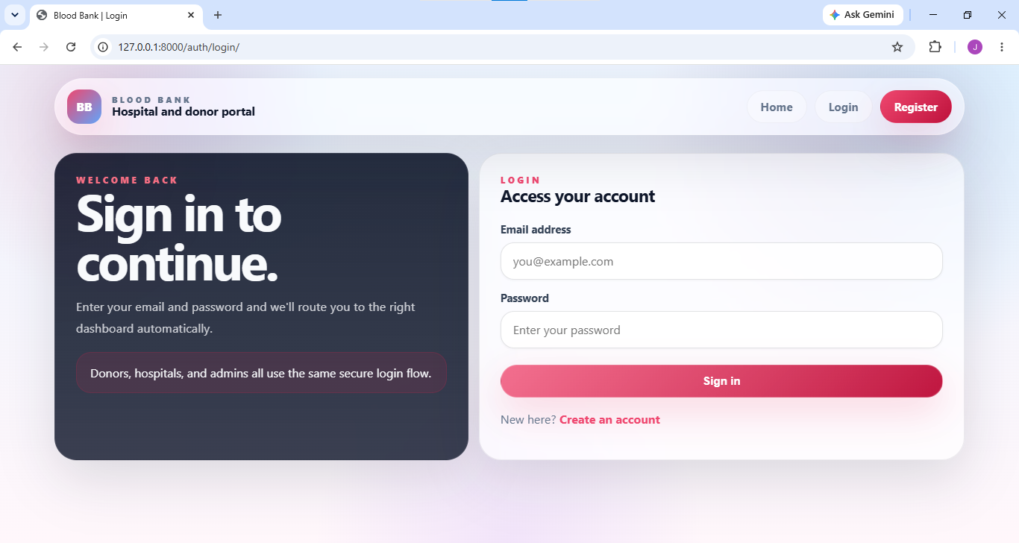
Admin Page
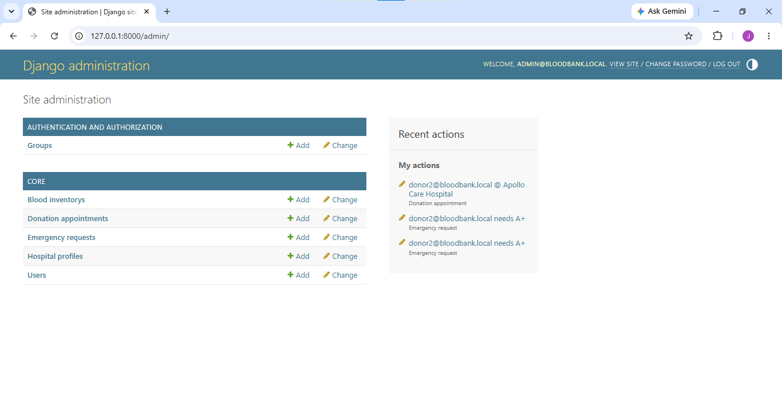

Hospital Dashboard
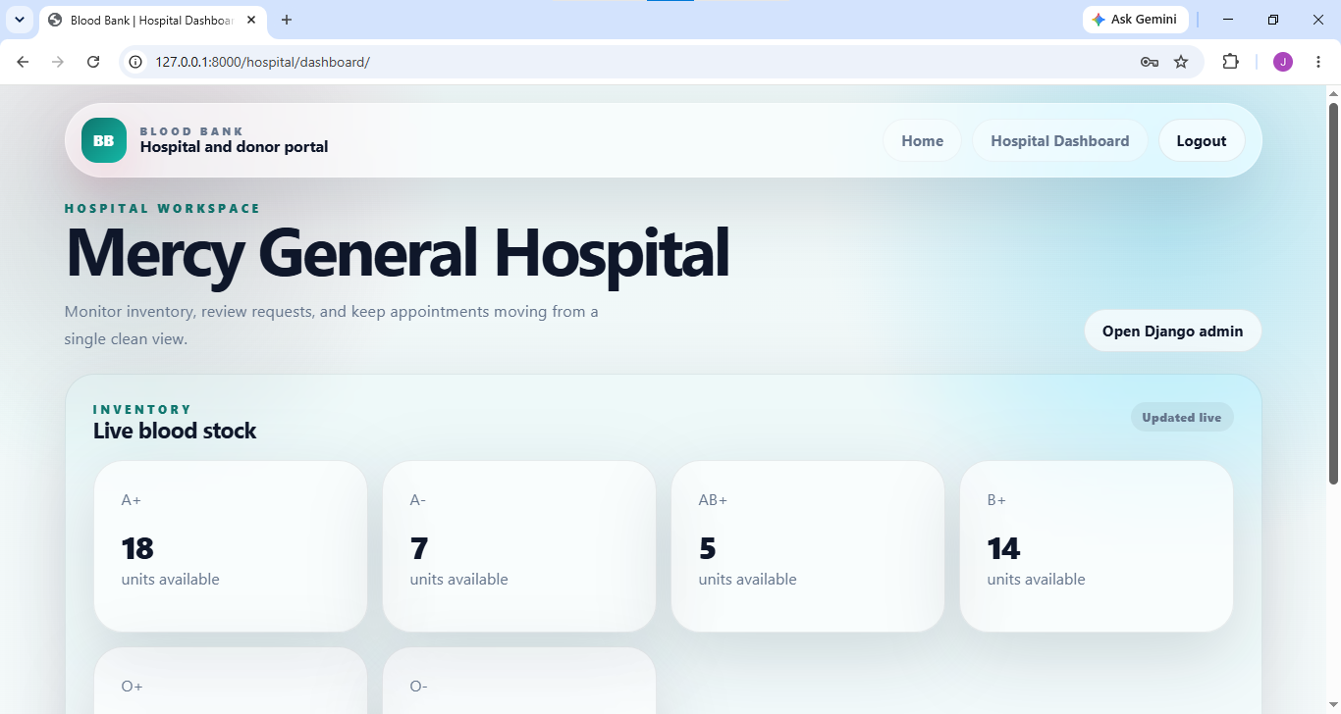
Donor Dashboard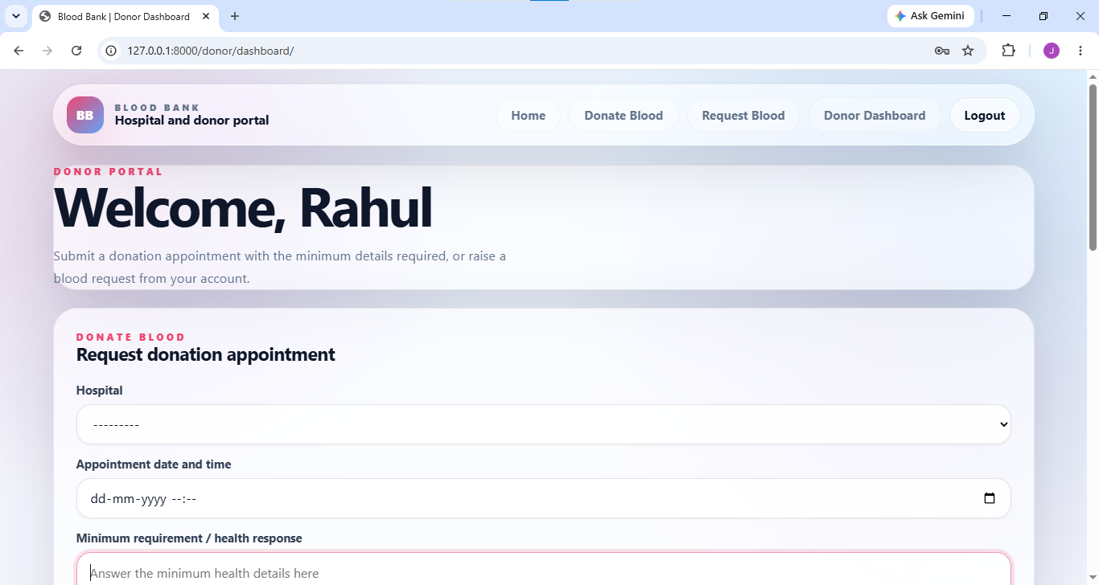

Donor Blood Request
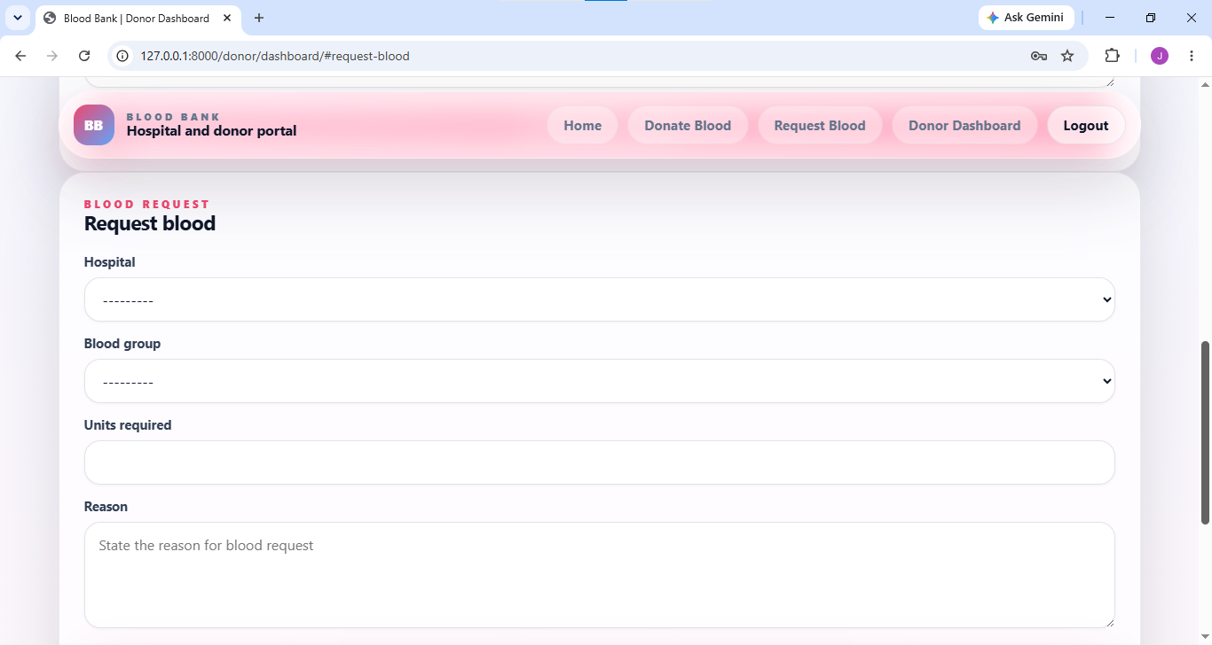
Donor Blood Donation request
